***Electronics and Communications Department***

***Analog Electronics***

**LAB 2&3 Notes**

**FREQUENCY RESPONSE**

|  |  |
| --- | --- |
| Name | عبدالرحمن علي موسى |
| Sec | 4 |

* **Part 1: Frequency response of Single-Stage CE Amplifier**
* **Circuit:**

* **at Frequency= 10 Hz:**

output Voltage=43.88 mV

Voltage Gain=43.88/10=4.388

Gain in dB=12.8 dB

* **at Frequency= 50 Hz:**

output Voltage=48.38 mV

Voltage Gain=48.38/10=4.838

Gain in dB=13.7 dB

* **at Frequency= 500 Hz:**

output Voltage=48.38 mV

Voltage Gain=48.38/10=4.838

Gain in dB=13.7 dB

* **at Frequency= 1 MHz:**

output Voltage=48.5 mV

Voltage Gain=48.5/10=4.85

Gain in dB=13.71 dB

* **at Frequency= 10 MHz:**

output Voltage=45 mV

Voltage Gain=4.5

Gain in dB=13.06 dB

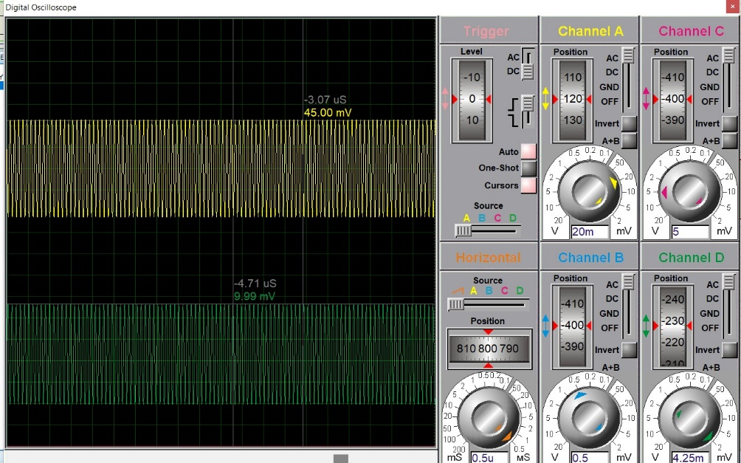

* **Table:**

|  |  |  |  |
| --- | --- | --- | --- |
| Frequency (Hz) | Vout (mV) | Gain | Gain in dB |
| 10 Hz | 43.88 mV | 4.388 | 12.8 dB |
| 50 Hz | 48.38 mV | 4.838 | 13.7 dB |
| 500 Hz | 48.38 mV | 4.838 | 13.7 dB |
| 1 MHz | 48.5 mV | 4.5 | 13.71 dB |
| 10 MHz | 45 mV | 4.5 | 13.06 dB |

* **Part 2: Frequency response of Two-Stage CE Amplifier**
* **Circuit:**

* **at Frequency= 100 Hz:**

output Voltage V3=2.80 mV

Voltage gain V3/V1=2.8

Gain in dB=8.9 dB

* **at Frequency =500 Hz:**

output Voltage V3=3 mV

Voltage Gain V3/V1=3

Gain in dB=9.5 dB

* **at Frequency=100 KHz:**

output Voltage V3=3 mV

Voltage Gain V3/V1=3

Gain in dB=9.5 dB

* **at Frequency =500 KHz:**

output Voltage V3=3 mV

Voltage Gain=3

Gain in dB=9.5 dB

* **at Frequency= 1MHz:**

output Voltage V3=2.8 mV

Voltage Gain V3/V1=2.80

Gain in dB=8.9 dB

* **Table:**

|  |  |  |  |
| --- | --- | --- | --- |
| Frequency (Hz) | Output Voltage V3 (mV) | Gain | Gain in dB |
| 100 Hz | 2.80 mV | 2.8 | 8.9 dB |
| 500 Hz | 3 mV | 3 | 9.5 dB |
| 100 KHz | 3 mV | 3 | 9.5 dB |
| 500 KHz | 3 mV | 3 | 9.5 dB |
| 1 MHz | 2.80 mV | 2.8 | 8.9 dB |